# 

***Whispers of the American West: Desert Rain God***

**Level 13 Design Document**



Written by: Theresa Devine and Richard Griffin

Version: *02.01*

Date: *03/22/2021*



Copyright 2018-2021 *Studio 4 Game Innovation*. All Rights Reserved.

Do not Duplicate or Distribute without the express permission of the copyright holder.

This document is considered to be CONFIDENTIAL and PRIVATE.

# TABLE OF CONTENTS

TABLE OF CONTENTS 2

VERSION HISTORY 4

01.00.00 4

02.00.00 4

02.01.00 4

INTRODUCTION 5

CONCEPTUAL DEVELOPMENT 5

WHISPERS OF THE AMERICAN WEST: WORLD DIAGRAM 6

OVERVIEW OF LEVEL DESIGN (DESERT RAIN GOD) (In Progress) 7

LEVEL DESIGN DIAGRAM 7

MISSION DESIGN LIST (TO DO) 11

ACCESSIBILITY & USE 11

USER CHARACTERISTICS 11

USER OBJECTIVES 12

INCLUSION 12

GAME REQUIREMENTS 13

USE CASE DIAGRAM (TO DO) 14

USE CASE NARRATIVE (TO DO) 14

VISUAL ARCHITECTURE 15

AESTHETICS (TO DO) 15

COLOR THEORY (TO DO) 15

TYPOGRAPHY (TO DO) 15

BUTTON MAP 16

USER INTERFACE (TO DO) 16

NAVIGATION HIERARCHY*.* 17

Screen [1.0]: Player Start 17

Screen [1.1]: Player explores the North Wing 17

Screen [1.2]: Player approaches painting 18

Screen [2.0]: Player Start in the Desert Rain God Level 18

Screen [2.1]: Player explores the level. 19

Screen [2.3]: Player finds the abandoned mine. 20

ENVIRONMENT DESIGN 20

Actual Claim 28 Site Photos 20

General Mine Photos – Navajo Nation 24

General Mine Photos – Utah 27

VISUAL CHARACTER DESIGN (Little Rain God) (TO DO) 29

SONIC ARCHITECTURE 30

SOUND EFFECTS: STINGERS 30

SOUND EFFECTS: TAGS 30

MUSIC: INTRO (TO DO) 30

MUSIC: LOOP (TO DO) 31

MUSIC: TRANSITION (TO DO) 31

SOFTWARE GAMEPLAY DESIGN AND ARCHITECTURE 31

LOGICAL VIEW (TO DO) 34

DATA VIEW (TO DO) 34

LOCALIZATION (TO DO) 34

INSTRUMENTATION VIEW (TO DO) 34

SECURITY VIEW (TO DO) 34

# VERSION HISTORY

*About version numbers:*

*XX.YY.ZZ format*

*XX – major revisions, new sections, complete section revisions*

*YY – revisions to existing sections, major and minor*

*ZZ – small corrections, typos, grammar, formatting, etc.*

## 01.00.00

Written by Alvin Thai, Maedsyn Matthews, Ian McGonigle, Rinaldo Del Gallo (IAP 220: Introduction to Game Studies, Fall 2020)

*Added*: Initial Documentation

*Software Gameplay Architecture, Sonic Architecture, Visual Architecture, Accessibility and Use, Introduction*

## 02.00.00

Written by Theresa Devine and Richard Griffin (02/24/2021: NCUIRE Grant Spring 2020)

Added Conceptual Development section and researched concept and gameplay.

* Outcomes:
  + Environment design to be based on Abandoned Uranium Mines on the Navajo Nation Reservation
  + Gameplay mechanic – perspective altering puzzles
  + Conceptual basis – the Treaty of 1868 is still in effect and was what made it legal to mine on Navajo land. Article Article IX, section 6 gives the US permission.

## 02.01.00

Written by Theresa Devine and Richard Griffin (03/22/2021: NCUIRE Grant Spring 2020)

Updated:

* Title page, Introduction, Conceptual Development, World Diagram, Overview of Level (unfinished), Level Design Diagram, User Characteristics, User Objectives, Environment Design, and Sonic Architecture. Moved brainstorming for gameplay to Software Gameplay Architecture from the Conceptual Development section. Added a sketch for the main mechanic in the game.

Added:

* Melissa Bridges design to the World Diagram (IAP 220: Introduction to Game Studies, Fall 2020)
* Added Goals and Challenges to the Alignment Grid in the Overview
* Added Game Requirements 18-22

# INTRODUCTION

The painter of *Desert Rain God*, Louisa McElwain, was fascinated by the way light changes when a storm comes in the American Southwest. The location of the painting appears to be in New Mexico, approximately somewhere on the Navajo Nation land. As Louisa McElwain studied the landscape and the light to create this painting, she was unaware of the political, social, and cultural significance of this land. This painting is an example of historical amnesia.

In designing this level of the game, we answer the call of Nikki Sanchez, a Pipil/Maya and Irish/Scottish academic, Indigenous media maker and environmental educator to face this historical amnesia. We aim to learn: 1) What treaties are important and why? 2) What system of oppression is still alive today because of that broken treaty? 3) What action can be taken today?

This historical trauma is all of ours, and in this level of the game, we aim to teach the answers to these questions towards building a better tomorrow and encourage a renewed discussion about the issues of uranium mining, pollution, and reversing the damage on the land of the Diné.

## CONCEPTUAL DEVELOPMENT

|  |
| --- |
| Information provided by Phoenix Art Museum Education Dept.  About the art: 54 × 72 in. (137.2 × 182.9 cm)  Museum purchase with funds provided by Betty Van Denburgh in honor of Western Art Associates. <https://heard.org/bluemoon/>  What the docents are currently teaching about the piece.   * In 19th century, women were not part of the great enthusiasm for landscape painting, but in the twentieth and twenty-first century women reclaimed it * The artist worked outside, *en plein air*, directly in contact with the landscape of Northern New Mexico * Bold, expressive style: she worked with palette knives and masonry trowels |

In the location that the painting was created, the Naal Tsoos Saní (The Old Paper): The Navajo Treaty of 1868 is the treaty is still in effect today. It has not yet been fully honored.

Article IX, section 6 of the Treaty states:

“They will not in future oppose the construction of railroads, wagon roads, mail stations, or **other works of utility or necessity** which may be ordered or permitted by the laws of the United States; but should such roads or other works be constructed on the lands of their reservation, the government, **will pay the tribe whatever amount of damage** may be assessed by three disinterested commissioners to be appointed by the President for that purpose, one of said commissioners to be a chief or head man of the tribe.”

[http://www.uintahbasintah.org/usdocuments/doc33.pdf](https://urldefense.com/v3/__http:/www.uintahbasintah.org/usdocuments/doc33.pdf__;!!IKRxdwAv5BmarQ!MhMvAsehS37uMRoite4yKIZkOexffNCAoy0kJYX3KEx0vK_JCwpywlrE9Xjb-AyUsEjlwmE$) (last accessed 03-22-2021)

It is this provision that allowed the US from 1944 to 1986, to extract nearly 30 million tons of uranium ore from Navajo lands under leases with the Navajo Nation. The abandoned mines are the source uranium contamination. This contagion has affected the water, homes, health, and future of the Diné. While there is an effort to clean up the pollution, the work of the US has been inadequate to date.

*524 Mines: The threat on the Navajo Nation*: <https://youtu.be/_cvt34m7tTk>

* <https://www.epa.gov/navajo-nation-uranium-cleanup/abandoned-mines-cleanup> (last accessed 03-22-2021)

The work of Navajo storyteller Sunny Dooley and nuclear nonproliferation expert and founder of Bombshelltoe Lovely Umayam influence this project. “*Ways of Knowing* is a creative attempt to bridge policy and humanity in examining the United States’ nuclear weapons production legacy … [and] serves as a reminder that nuclear weapons are not just made of secrecy, science, and steel; their power is in part derived from a naturally occurring element extracted from the Earth at the expense of Indigenous lives.”

* <https://waysofknowing.us> (last accessed 03-22-2021)
* <https://bombshelltoe.com> (last accessed 03-22-2021)

The gameplay design will be influenced by *Hozho: Dine’ Concept of Balance and Beauty.* “Living in, or as sa’ah naaghaii bik’eh hozho means continually restoring, finding, and practicing balance in one’s daily life. The ability to live in balance is gained primarily through acquisition of knowledge. It is the possession of knowledge that makes one ‘divine,’ by virtue of putting one in closer contact with and able to better utilize the basic energetic forces underlying nature (Farella, 1093:24). The knowledge is acquired through ritual, stories, songs and experience in life, including all the good and bad of life.”

* <http://johnnyhozho.blogspot.com/2012/07/hozho-dine-concept-of-balance-and.html>
* <https://www.amazon.com/Main-Stalk-Synthesis-Navajo-Philosophy/dp/0816512108>

(last accessed 03-22-2021)

## WHISPERS OF THE AMERICAN WEST: WORLD DIAGRAM

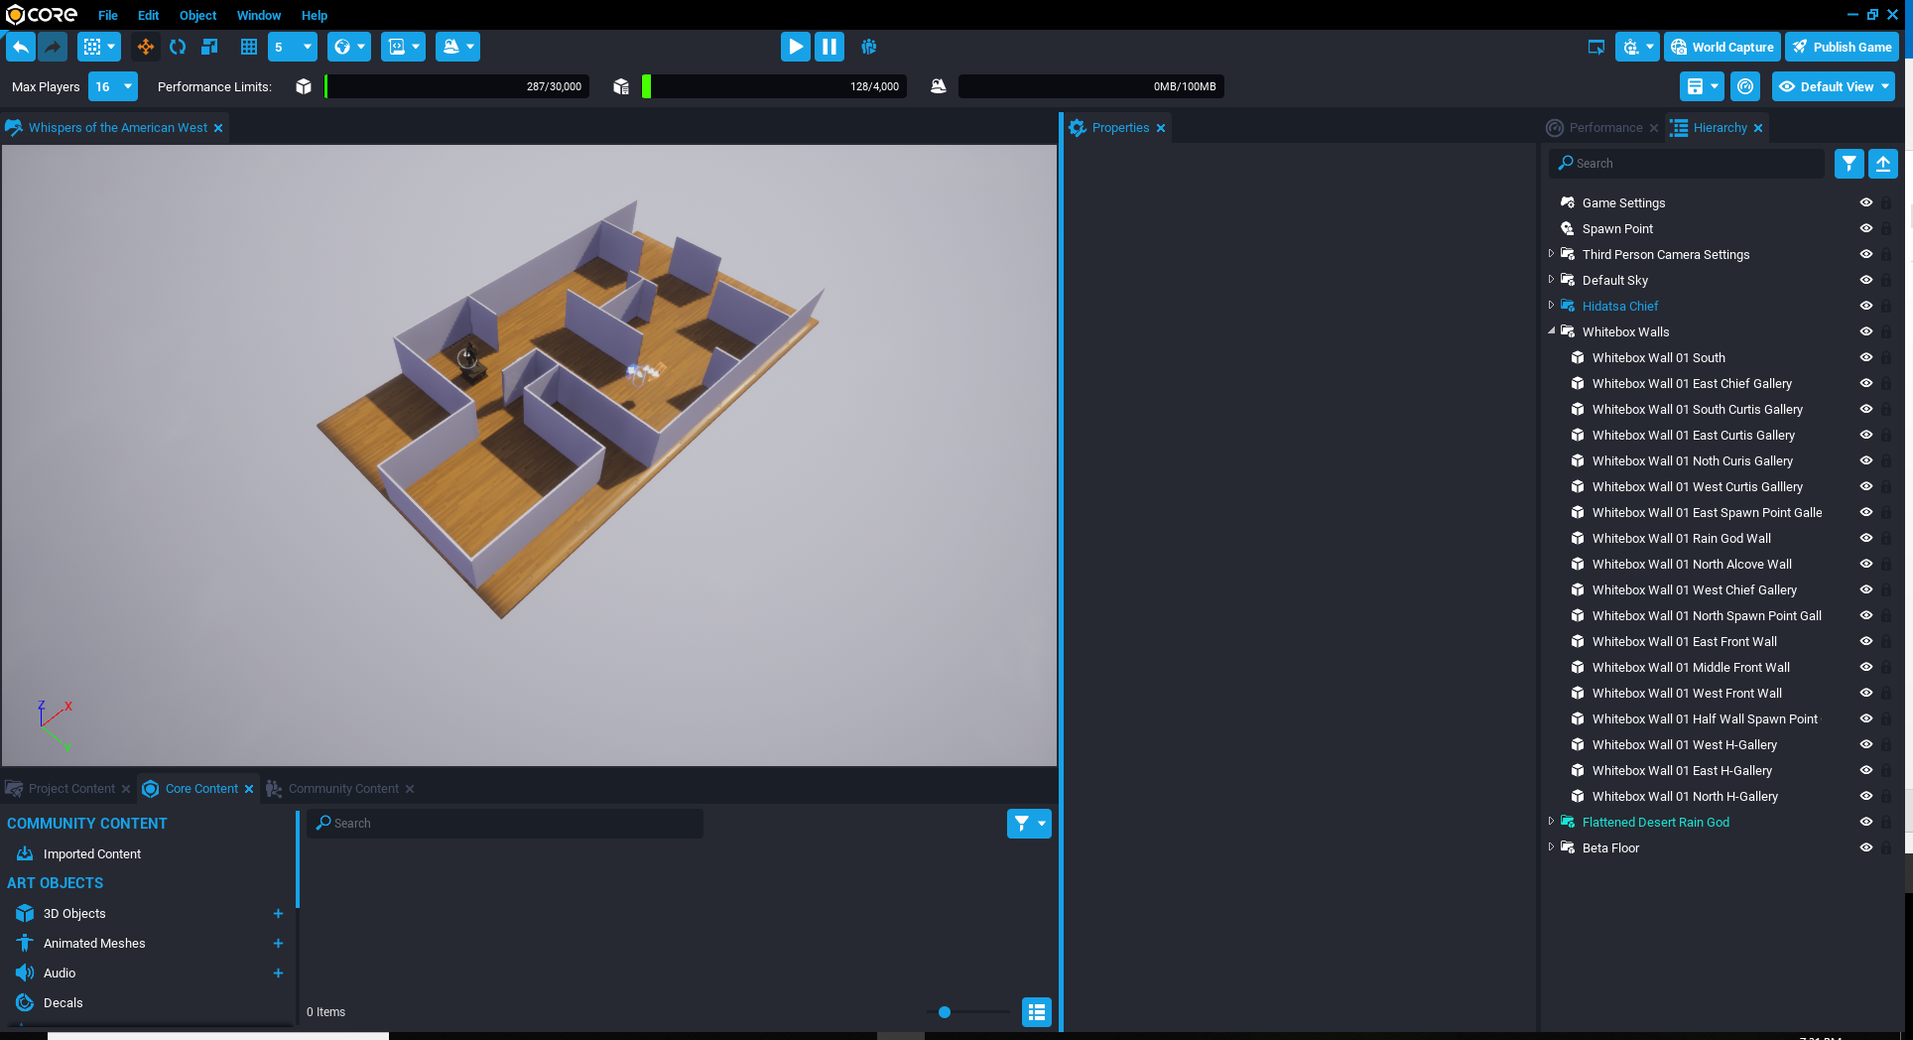

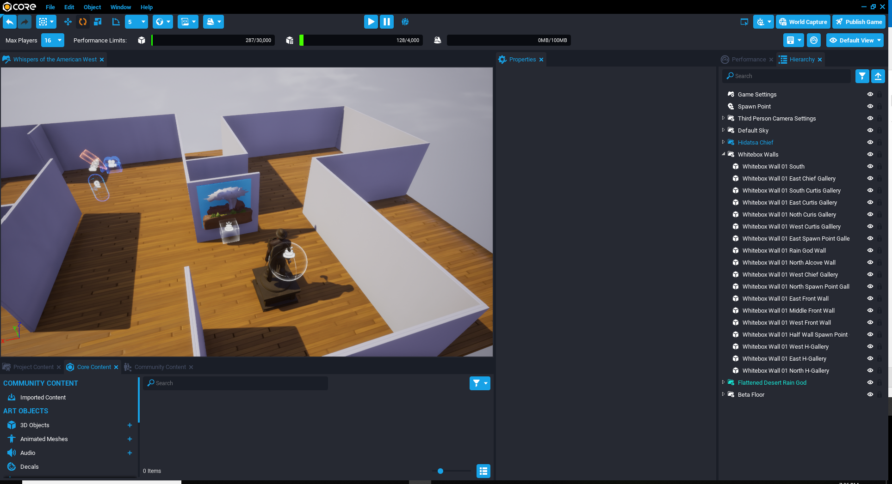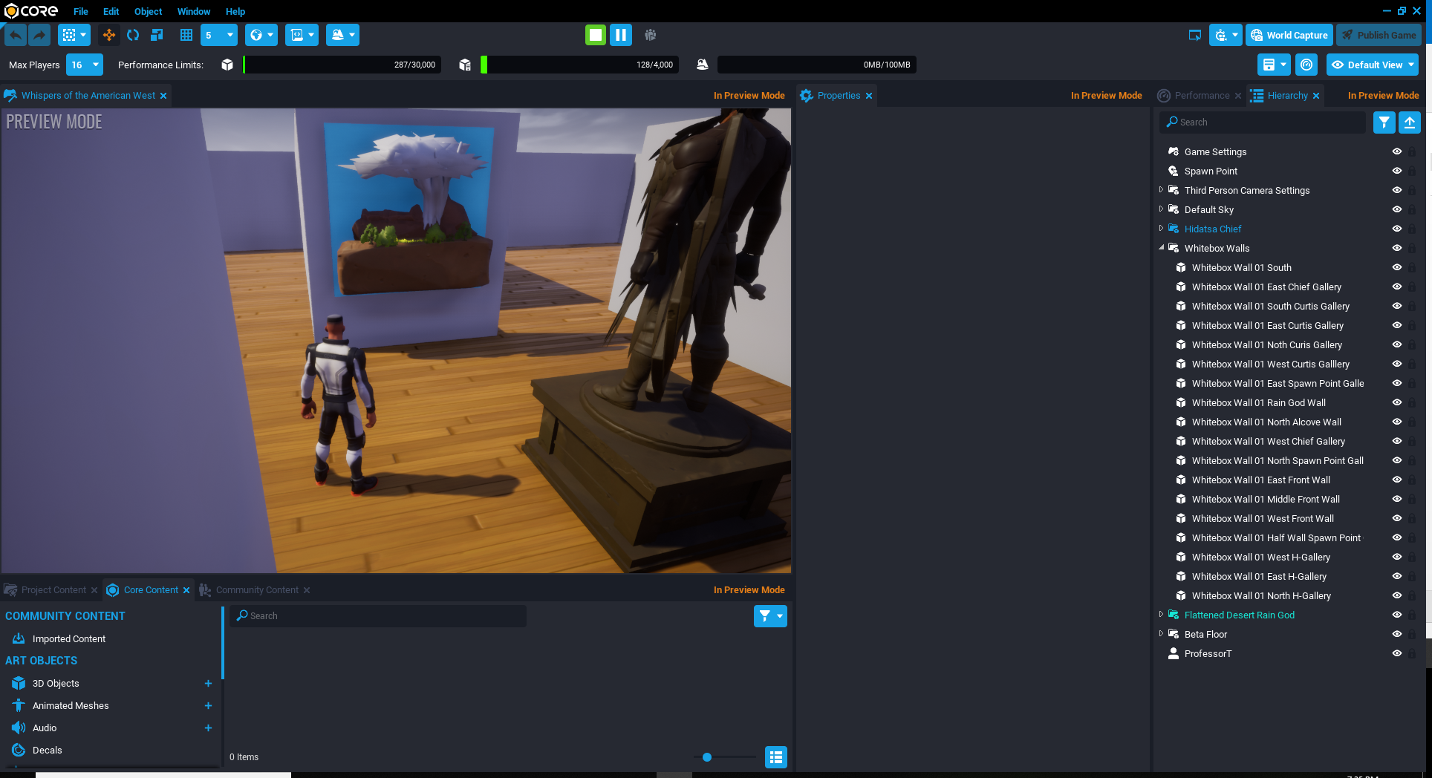When player approaches the painting in the hub level: wind rolls in, lightning starts, and thunder sounds. After a 3 second delay on lightning the name of Piece pops in. After a 3 second, delay the name of artist rolls in and thunder sounds again. Designed by Melissa Bridges (IAP 220: Introduction to Game Studies, Fall 2018, Level Design Document date: 09-27-2018)

## OVERVIEW OF LEVEL DESIGN (DESERT RAIN GOD) (In Progress)

## 

Notes on the design of the gameplay: Magic in the landscape (appearing mountain experience near Diné College, Devine); Hidden pathways that are revealed via exploration. Certain landscape features offer unique perspective that specifically reveal these pathways. (Griffin)

|  |  |  |
| --- | --- | --- |
| Level 18,  [Desert Rain God](https://phxart.org/arts/desert-rain-god-dios-de-la-lluvia-en-el-desierto/) | **Goal:** Restoring balance  Rules: The sun will be released for movement based on gaining a piece of knowledge about the provision in the treaty, uranium mining, pollution, and reversing the damage  Mechanics: Shadow Illusion by moving Sun  Plot Point: a renewed discussion about the issues of uranium mining, pollution, and reversing the damage on the land of the Diné | **Challenge:** Acquisition of knowledge  Strategy: (TO DO)  Tactics: (TO DO)  Skills: Bloom’s Taxonomy  Applying: Judging, Experimenting  Analyzing: Correlating, Mind-Mapping  Evaluating: Assessing, Measuring, Predicting |

*.*

## LEVEL DESIGN DIAGRAM

The following landmarks demarcate the traditional lands of the Diné.

**Four defining mountains**

* Blanca Peak (Sis Naajini); Mount Taylor (Tsoodzil); San Francisco Peaks (Dook’oosliid); Mount Hesperus (Dibe Nitsaa)

**Central Mountains**

* Gobernador Knob (Ch’ool’i’i), Huerfano Mountain (Dzil Na’oodilii)

Sources: (last accessed 03-22-2021)

* https://www.americanindianmagazine.org/story/naal-tsoos-sani
* Ch. 5.5 Navajo Current-Future Water Use 12-13-2018.pdf
* navajo_nation_settlement_fact_sheet-2020-11-19.pdf (EPA)

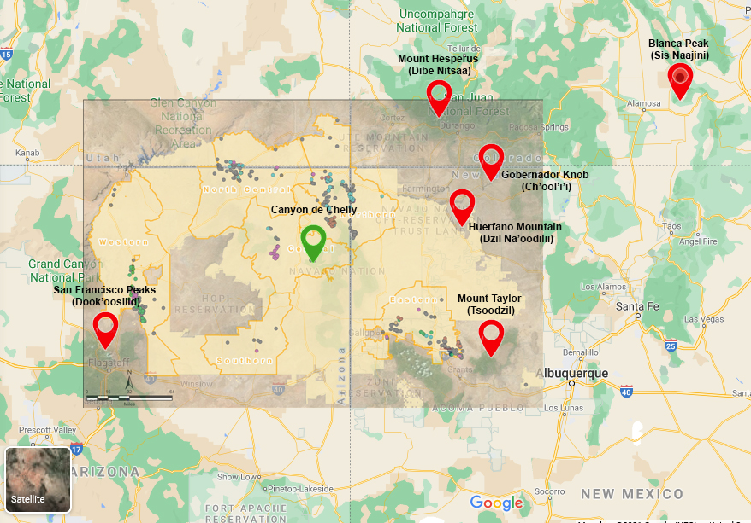

Abandoned Uranium Mines

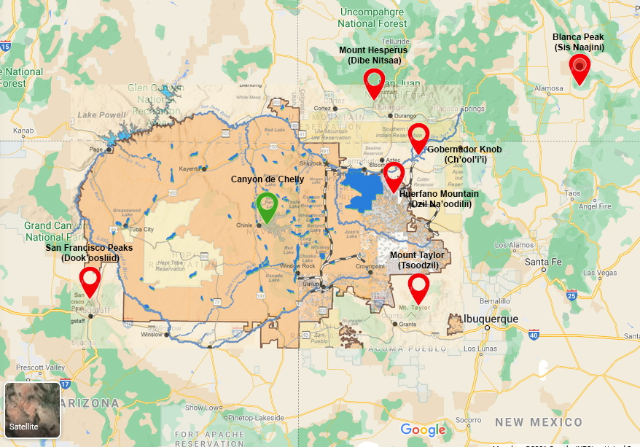

Water Futures, Blue is currently irrigated land

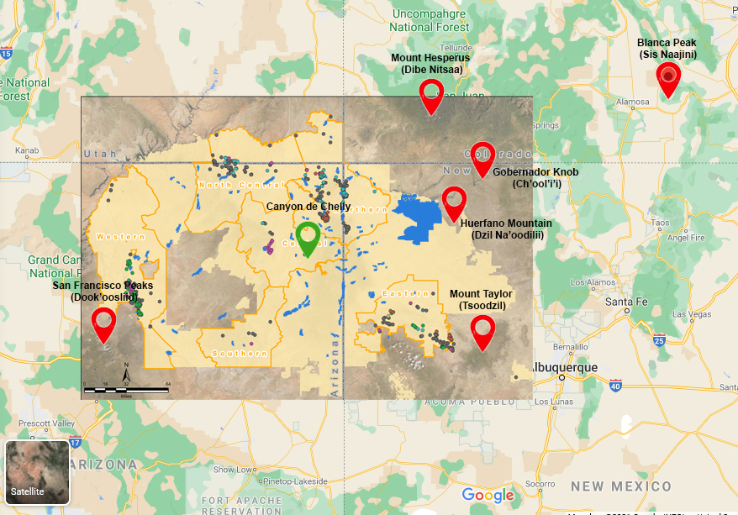

AUM + Water Future. Blue is currently irrigated land

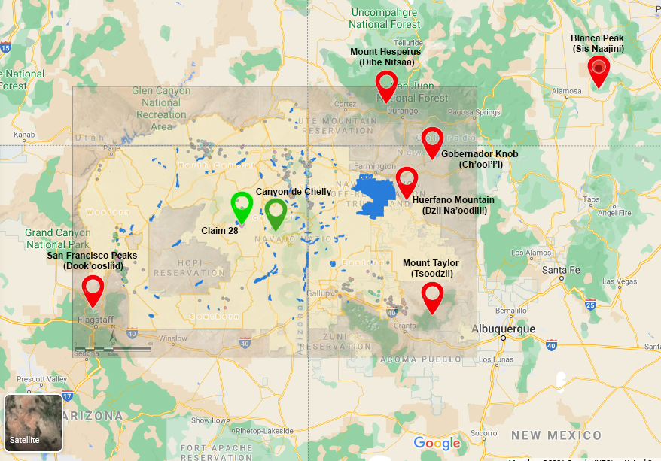

We will be concentrating on Claim 28 (79), which is located 37.8 miles west of Canyon de Chelly via Route 29.

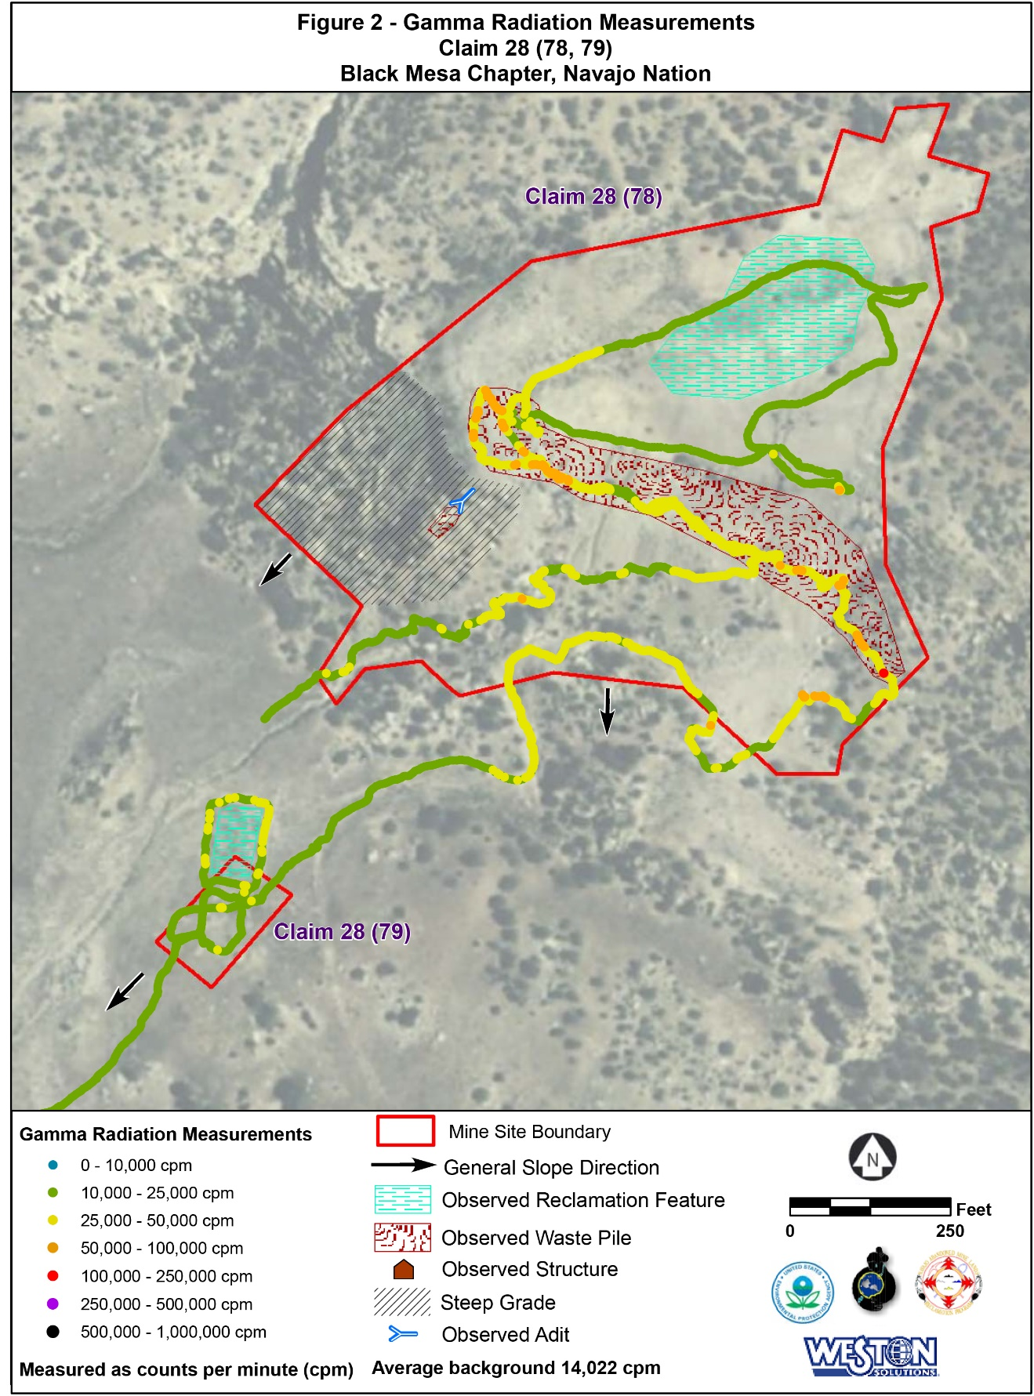

Page 15: <https://www.epa.gov/sites/production/files/2017-04/documents/78_79_Claim_28_AUM_Screening_Report.pdf> (last accessed 03-22-2021)

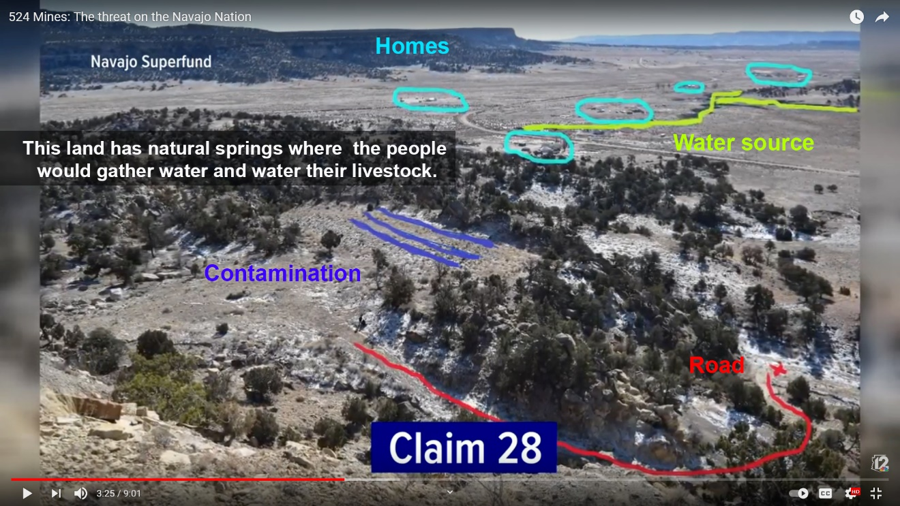

*524 Mines: The threat on the Navajo Nation*: <https://youtu.be/_cvt34m7tTk> (last accessed 03-22-2021)

## MISSION DESIGN LIST (TO DO)

|  |  |
| --- | --- |
| Name of Mission | Name of Mission Design Document |
|  |  |
|  |  |

# ACCESSIBILITY & USE

*According to these guidelines:* [*http://gameaccessibilityguidelines.com*](http://gameaccessibilityguidelines.com) *this level of the game will be made accessible according to the goals for accessibility the general inclusion strategies here.*

## USER CHARACTERISTICS

|  |  |  |
| --- | --- | --- |
| How many? | Title | Description of Characteristics |
| ?? | Casual Museum Attendees  (Adults, Parents, Kids) | All of these players will need no learning curve. These players are able to download and install the game on their phone (either Android or iPhone) and follow instructions to play the game. |
| 20 | Museum Docents | Are trained in educating the public about the collection. They will need further training in using the game. It should be simple for them as well. |
| 3 | Museum Educators | They manage the docents and the educational materials. They train and guide the Docents and the School Art Educators. |
| ?? | School Art Educators | Similar to the Docents, they are trained in the collection and will need training in using the game. |
| 5 | Museum Administrators | They oversee the entire initiative. They will play the game in order to review and approve it. |
| 10 | ASU student developers | Level Design and development of their assigned level. Will be new to game development in general. This will be a quickstart approach for them. |
| 1-3 | ASU Professors | Overall game design, research humanities and cultural studies for design, liaison between ASU student developers and the Phoenix Art Museum educators, guide the students to create a usable experience. |
|  | Community Partners and Contractors | Assets for gameplay, consultation on the environmental, political, social, and cultural studies for design. |

## 

## USER OBJECTIVES

|  |  |  |
| --- | --- | --- |
| Title | Description of Objectives | Workflow |
| Museum Educators | Initiate project, review requirements and approve, test the game for final approval, train docents, art educators. Liason between ASU Professor and the PAM Administration. | First, intermediary reviews, final approval. |
| ASU Professor | Write GDD and project template for Level Design Documents, guide ASU student developers. | Second, intermediary reviews and guidance. Final approval before PAM Educators approve. |
| ASU student developers | Write Level Design document for their assigned level. Use template provided by ASU Professor Devine, build an AR experience that will be a level in the game produced. | Third. Use GDD requirements to write Level Design Documents and develop a level for the game. Each student will have a credit line. They will be primarily concerned with the player use cases. |
| Museum Administrators | Will approve the game for release in the PAM. | Fourth |
| Museum Docents | Will use the game in their tours after release. | Fifth |
| School Art Educators | Will use the game in their lessons after release. | Sixth |
| Casual Museum Attendees (players) | Play the game for fun, discovery of hidden knowledge | Last |

## INCLUSION

|  |  |  |
| --- | --- | --- |
| Ability | Level (Basic, Intermediate, Advanced) | Strategy for inclusion |
| *Fine Motor* | *Basic* | *We will ensure controls are transferable to an adjusted keyboard.* |
| *Large Motor* | *Basic* | *We will ensure controls are transferable to an adjusted keyboard.* |
| *Cognitive* | *Basic* | *We will ensure the use of an easily readable default font size. We will use clear language.* |
| *Vision* | *Basic* | *We will ensure the use of an easily readable default font size and sounds to accompany key junctures in the progression of the game.* |
| *Hearing* | *Basic* | *We will ensure the use of visual indicators to accompany key junctures in the progression of the game* |
| *Speech* | *Basic* | *We will ensure that speech input is not required.* |
| *General* | *Basic* | *Custom difficulty levels will be implemented to ensure the maximum range of abilities will be able to play the game.* |

## GAME REQUIREMENTS

*These are the requirements for the game that will become the traceability matrix and will help the team communicate who are working on the game. There will be a scoping meeting with the team to determine which requirements will be built and which will be in the next release or iteration of the project.*

|  |  |  |  |  |
| --- | --- | --- | --- | --- |
| Done  (Y/N) | # | Requirement Description | Originator of Req. | Scope (In/Out) |
|  | 1 | The game shall be fun. | Phx Art Museum | In |
|  | 2 | The game shall be multiplayer | Theresa Devine | In |
|  | 3 | The game shall communicate the premise *Art Collections are a joyful celebration of humanity* | Phx Art Museum | In |
|  | 5 | The game shall be and Edutainment Video Art Game and/or have educational experiences that joyfully educate the public as to the diverse voices and contributions that formed the collection of the Phoenix Art Museum. | Phx Art Museum | In |
|  | 6 | The game shall have a rating of E for Everyone | Phx Art Museum | In |
|  | 8 | The game shall be developed by the IAP 220: Introduction to Game Studies at ASU | Theresa Devine | In |
|  | 9 | The game shall be aesthetically beautiful | Phx Art Museum | In |
|  | 10 | The game shall enhance the collection at the Phoenix Art Museum | Phx Art Museum | In |
|  | 11 | The game shall have a high degree of usability | Phx Art Museum | In |
|  | 12 | The game shall amplify marginalized voices. | Dean Sandrin | In |
|  | 13 | The game shall benefit Black Lives Matter and community by being actively anti-racist | Dean Sandrin | In |
|  | 14 | The game shall advance the University’s charter of inclusivity. | Dean Sandrin | In |
|  | 15 | The game shall make time and space for healing from racism to occur. | Dean Sandrin | In |
|  | 16 | The game shall use the guidelines for researchers on the shutdownstem.com website | Theresa Devine | In |
|  | 17 | The game shall avoid cliché and stereotypes | Theresa Devine | In |
|  | 18 | The game shall be readily available to the public for free | Theresa Devine |  |
|  | 19 | The game shall provide professional opportunity to students and game developers | Theresa Devine |  |
|  | 20 | The game shall use shadow illusion as one of its main mechanics | Theresa Devine |  |
|  | 21 | The game shall invite storytellers to contribute their work to the game experience | Theresa Devine |  |
|  | 22 | The game shall be inclusive of all ability types | Theresa Devine |  |

## USE CASE DIAGRAM (TO DO)

## USE CASE NARRATIVE (TO DO)

*Copy and paste this section for each of the use cases.*

|  |  |
| --- | --- |
| ***Details of the use case actors*** | |
| *Use Case Name:* |  |
| *Primary Actors:* |  |
| *Secondary Actors:* |  |

*Purpose:*

This use case occurs when a player initiates the game

*Trigger:*

The player or system requires opening the software.

*Pre-conditions:*

Using PC or Mac platform

*Basic Course:*

The splash screen appears and the player chooses to play, quit, or look at options

*Post-Conditions*:

Player enters the state of the game.

*Possible Alternate Flows:*

Exit out

# VISUAL ARCHITECTURE

## AESTHETICS (TO DO)

*The game is set in McElwain’s painting, so we will be making use of her depth and composition. The foreground is an excellent stage for the player character to move around from side to side and up and down because of the actual subject of the painting. For visual indicators, because the moving elements are designed to match as closely to the painting as possible, there will be a slight glow to indicate to the player what can be interacted with, so as to make it easier to distinguish without losing the impact of the color. For color blind accessibility, The glow indicating objects that can be interacted with will be different in value and texture from the background to prevent any reliance on the color.*

*Note: we might use something other than glowing for visual indicators*

## COLOR THEORY (TO DO)

In an effort to maintain the vision of McElwain, her palette will be honored in the design of elements the game team adds. Each color is selected to match those present in Desert Rain God to match the feeling of majesty with cool deep blues and purples set against the soft warm oranges, yellows, and tans of the desert background.

These colors will also serve to make the player character stand out against the background more, as the backdrop will begin as a de-saturated brown and beige colors that the little Rain God’s blue and purple tones will stand out against. As the contrast is lessened and the painting becomes more vibrant, it will serve to immerse the player more wholly in the world of the painting.

*Note:Josef Alber’s Interaction of Color will be implemented in some way.*

## TYPOGRAPHY (TO DO)

*The font used for the option, raindrop meter, and instructions will be from the Perpetua family of fonts, or a comparable serif font of equal weight that is available for licensing and within the Coregames engine. Perpetua is usable on Microsoft products for personal computer use. This choice was made because this family of fonts is easily readable, particularly as a serifed font, and it isn’t intense enough to distract from the primary focus of the game- the color progression. The backsplash for the raindrops is included to allow for the player to easily locate and then read the raindrop meter, and menus will also be on a backsplash, as the colors of the entire game will shift so much that a simple color difference will not be reliable enough for contrasting text from background. As there are no large blocks of text, rag, widows, and orphans will not be an issue. Additionally, standard kerning will be effective.*

## BUTTON MAP

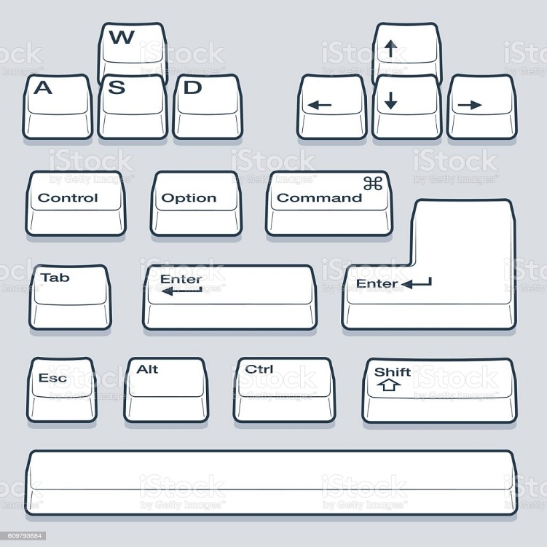

**

*Left arrow or A- move left*

*Right arrow or D - move right*

*Up arrow or W – move forward*

*Down arrow or S – move back*

*Space- Jump*

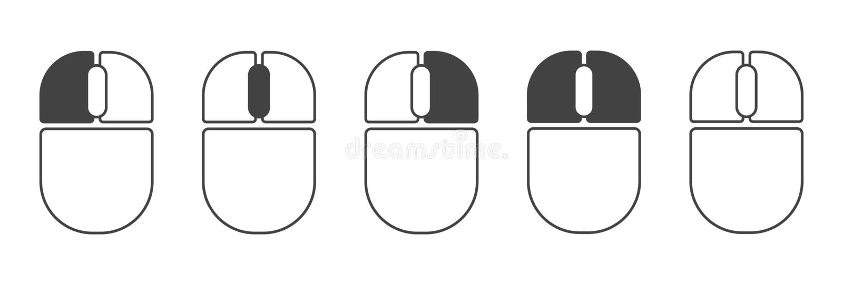

*Left Mouse button – Look or move camera*

## USER INTERFACE (TO DO)

*Simple, Passive interface that is meant more as indicators for the player of how much time, lives, and raindrops they have at any given point during gameplay. Elements that can be interacted with will retain their color and shape throughout the game to keep the player aware of what items they should be looking for.*

## NAVIGATION HIERARCHY*.*

### Screen [1.0]: Player Start

* is centrally located in the North Wing, Western Art Gallery of the Phoenix Art Museum

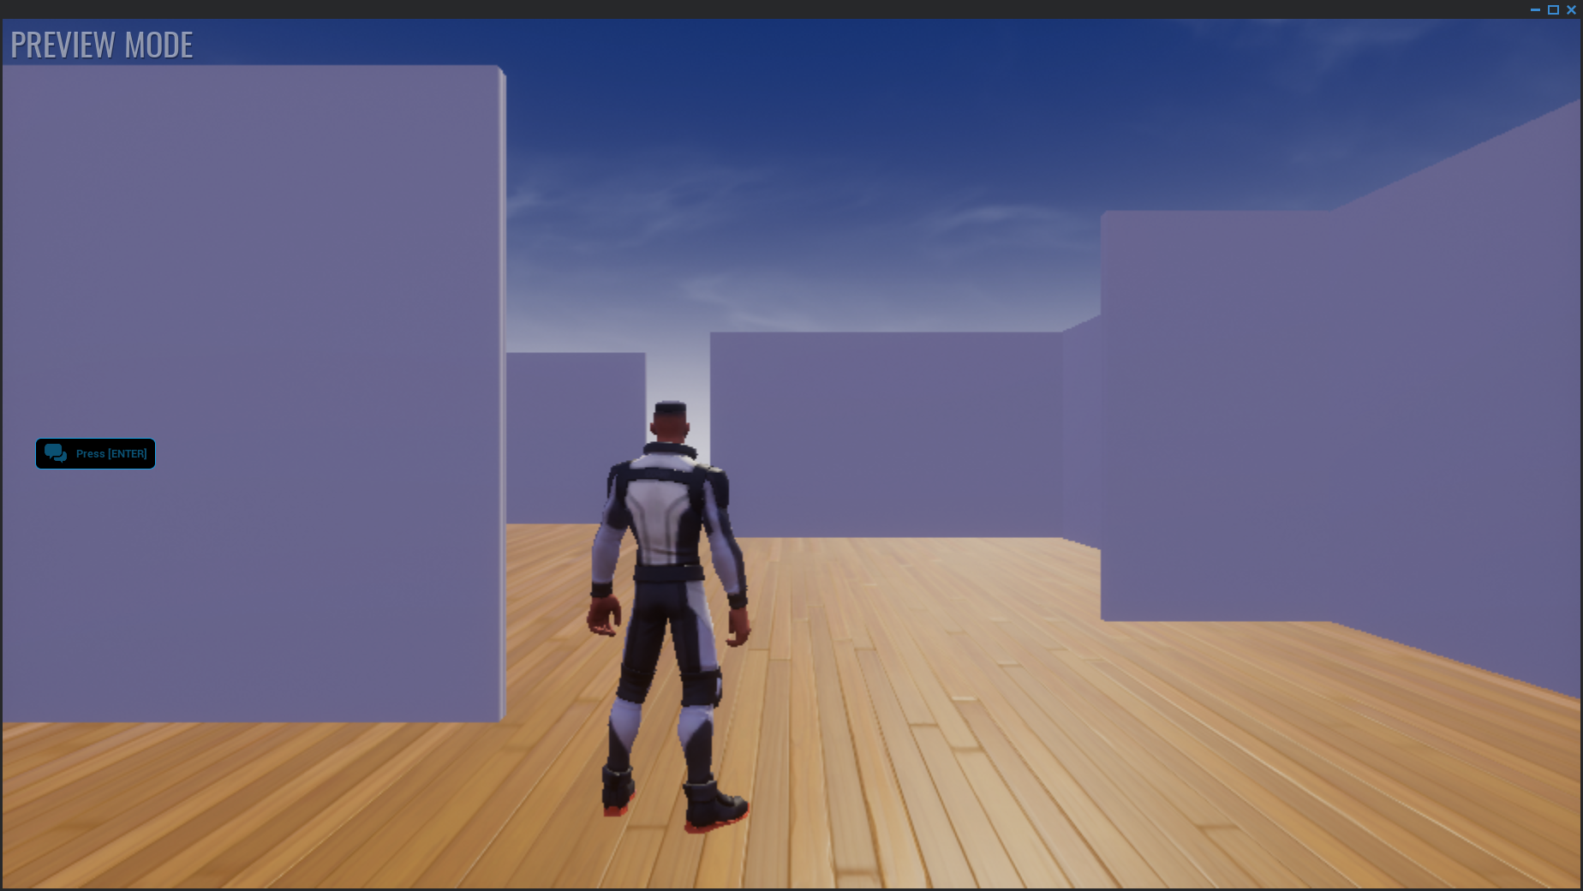

### Screen [1.1]: Player explores the North Wing

* Western Art Gallery of the Phoenix Art Museum to discover painting

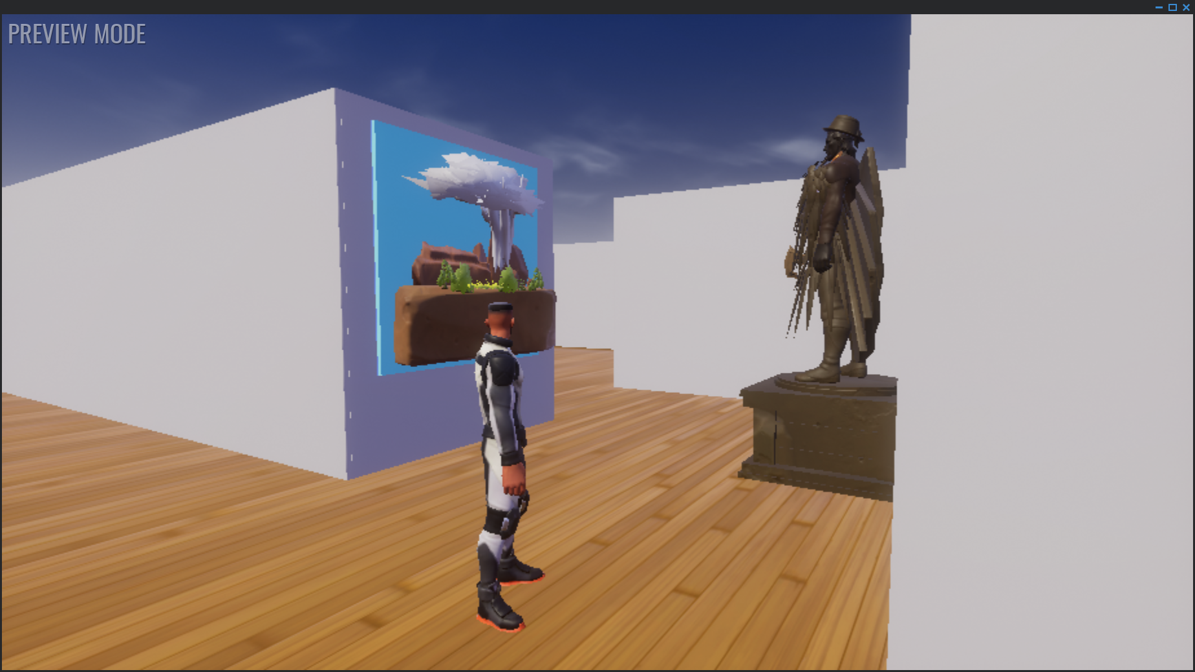

### Screen [1.2]: Player approaches painting

* and a trigger will automagically begin the thunder and lightning animation. A proximity trigger will transport the player into the Desert Rain God level.

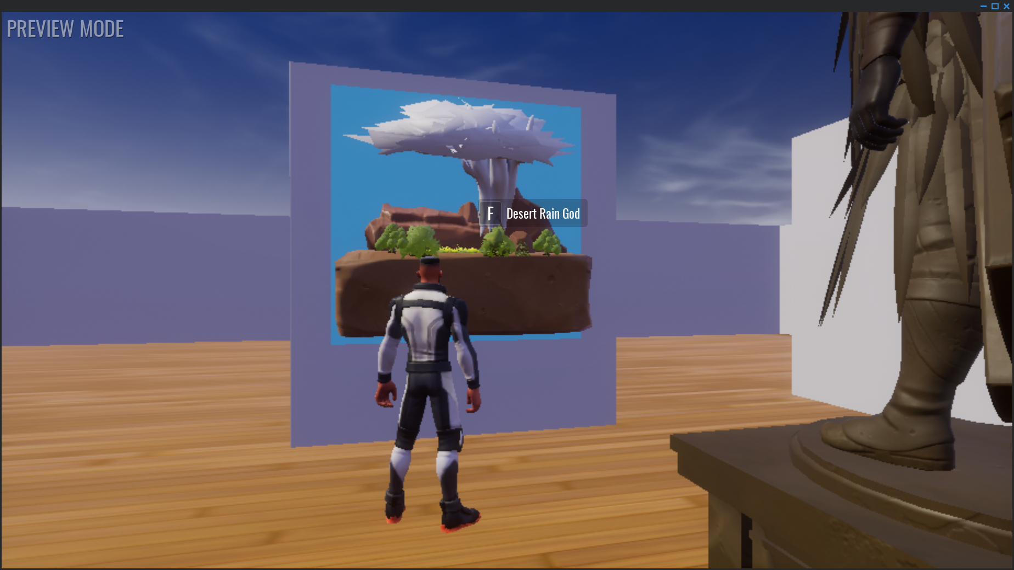

### Screen [2.0]: Player Start in the Desert Rain God Level

* is on a mesa. Player begins exploring the level.

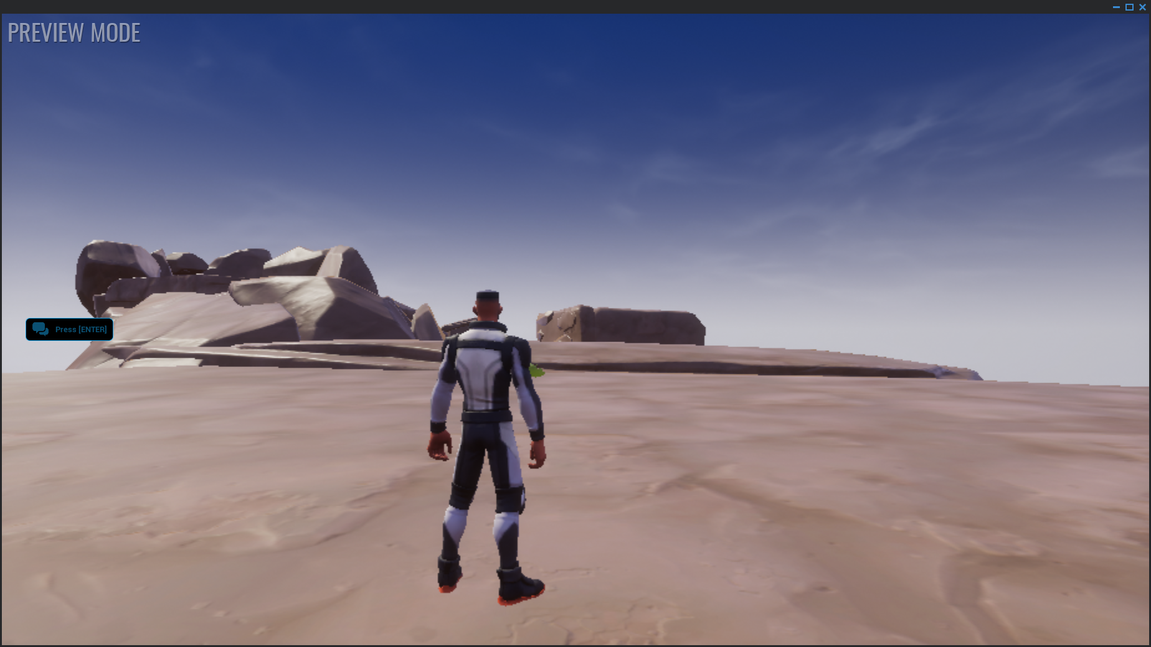

### Screen [2.1]: Player explores the level.

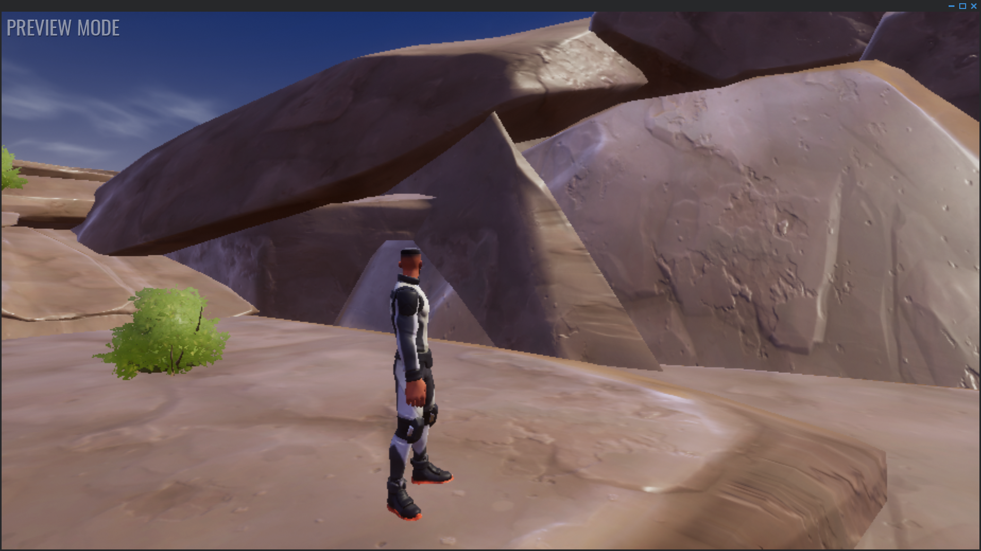

### Screen [2.2]: Player finds a hidden cave.

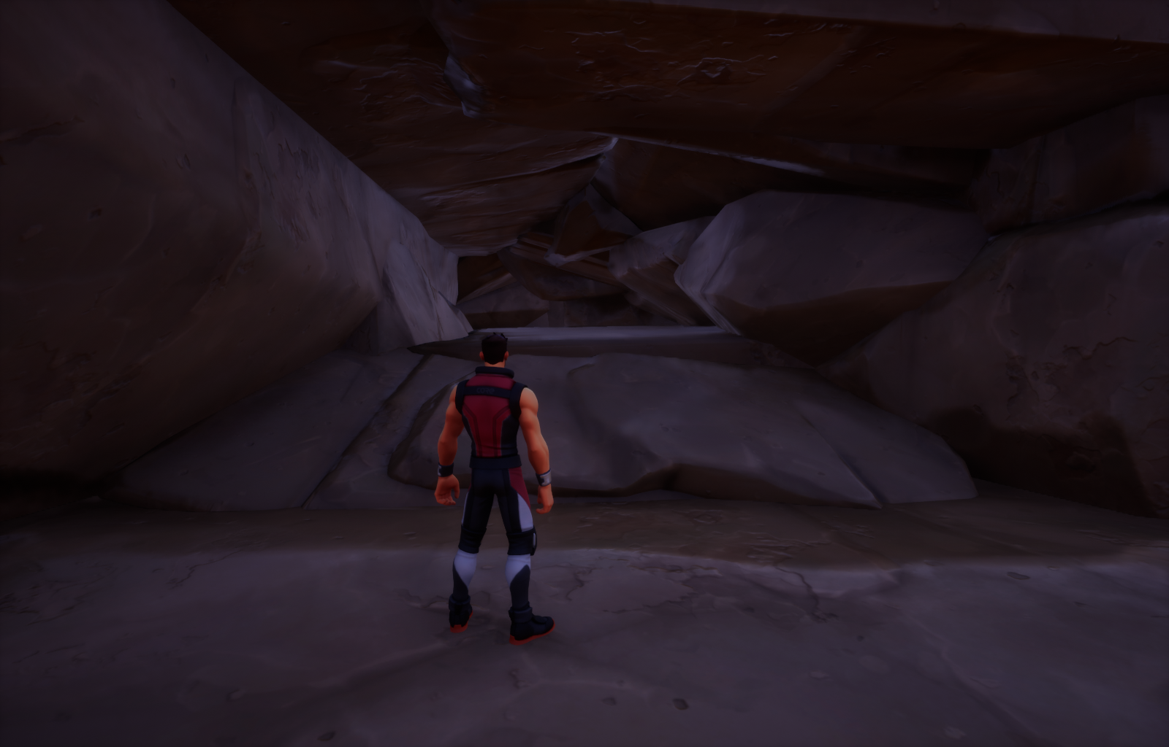

### Screen [2.3]: Player finds the abandoned mine.

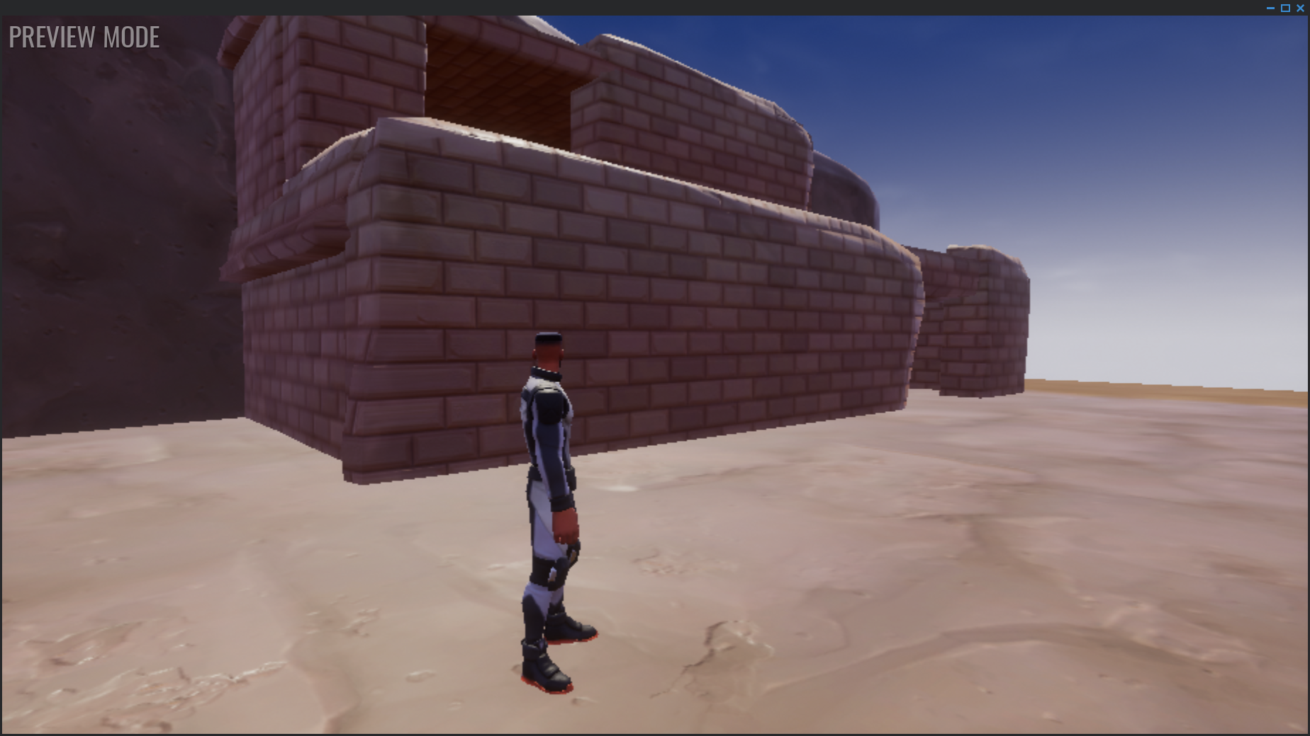

## ENVIRONMENT DESIGN

### Actual Claim 28 Site Photos

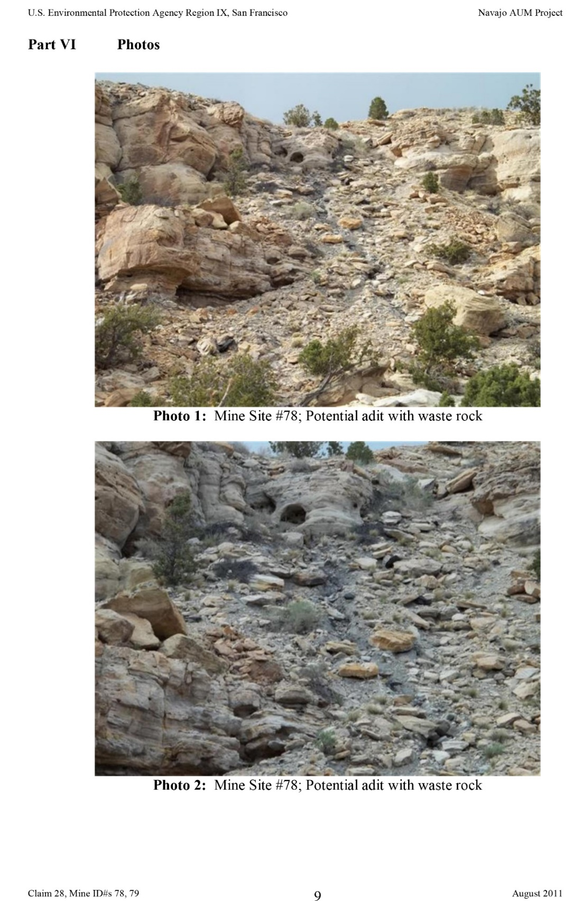

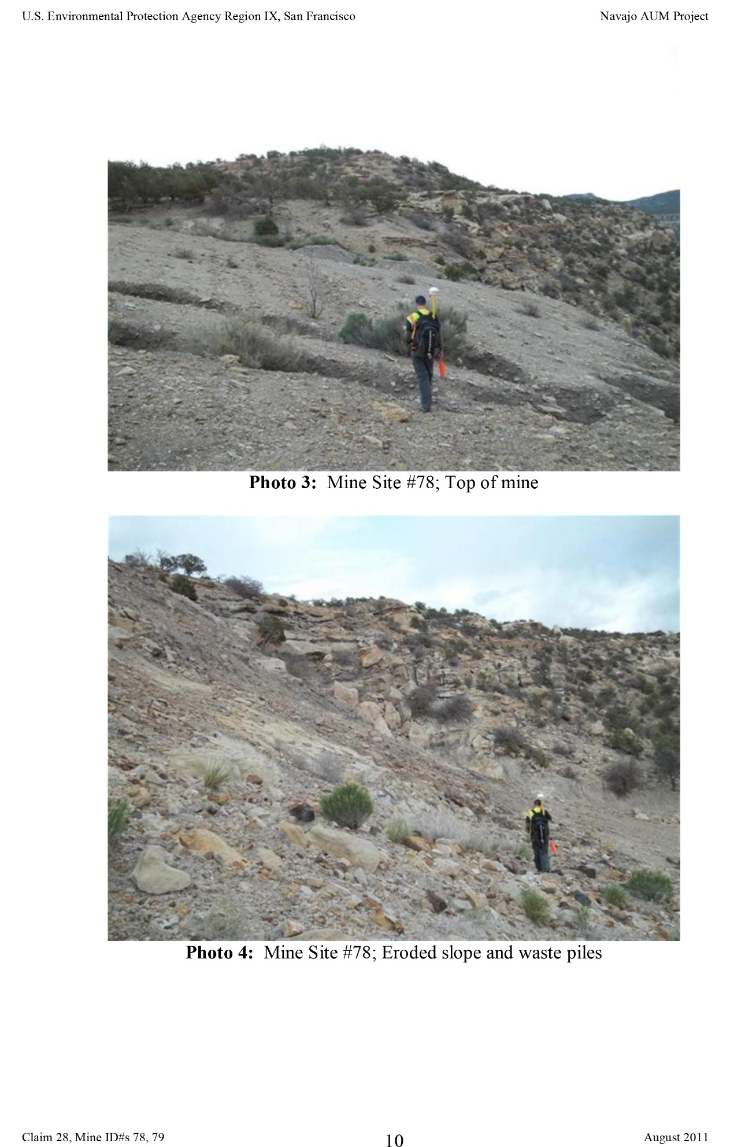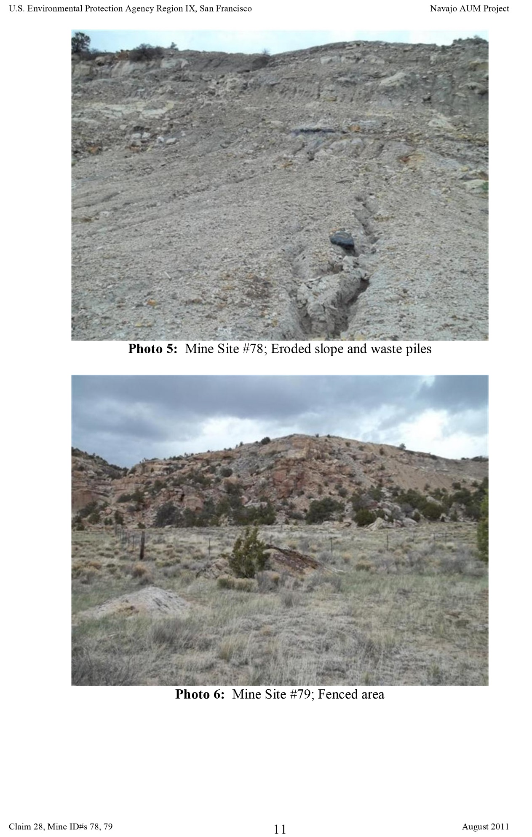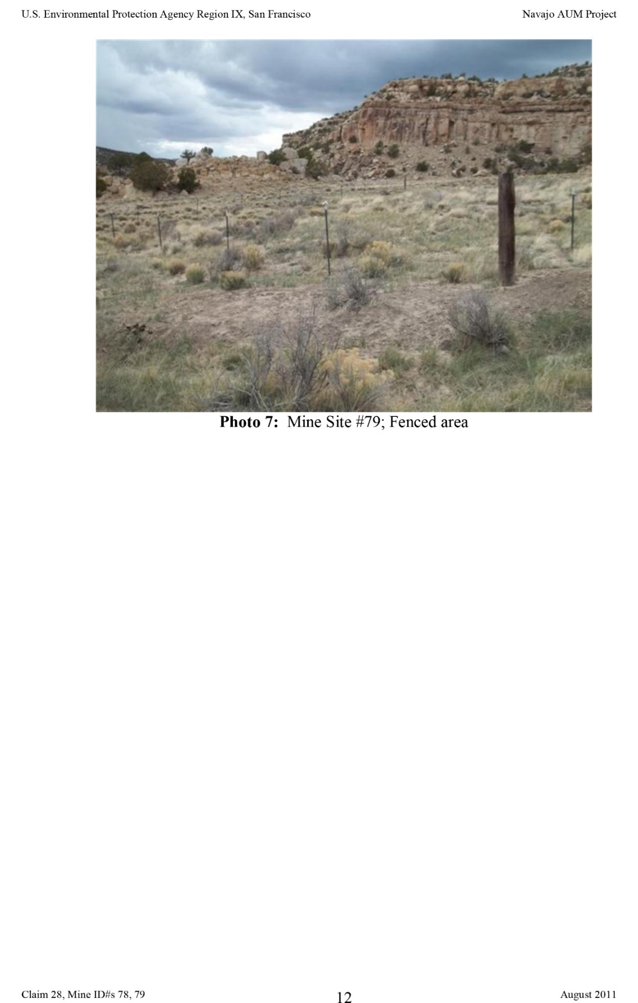

### General Mine Photos – Navajo Nation

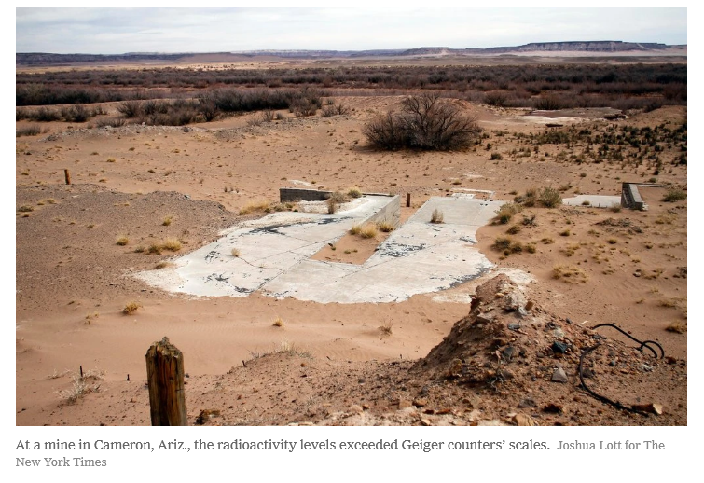

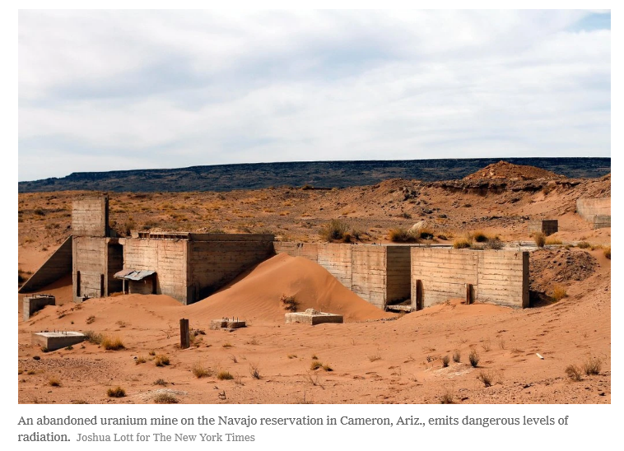

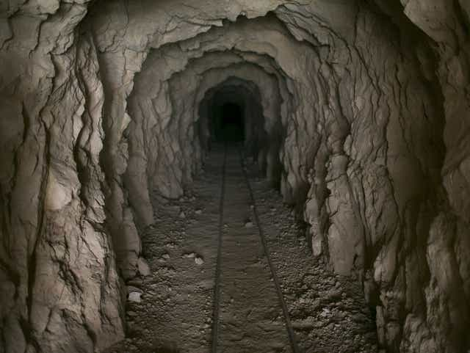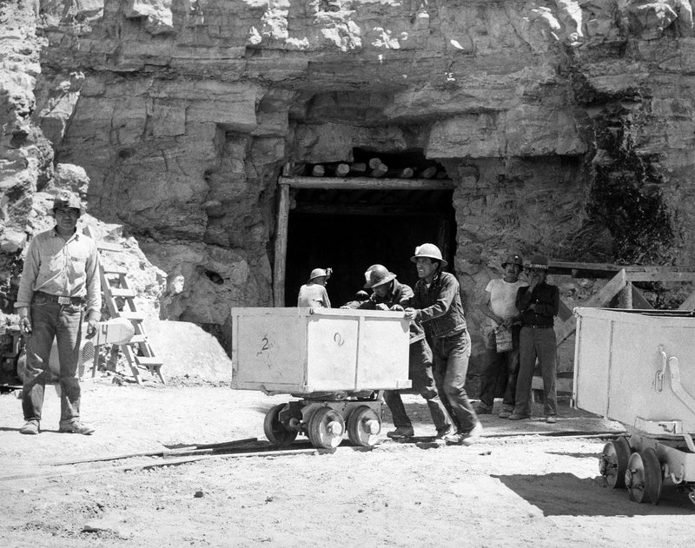

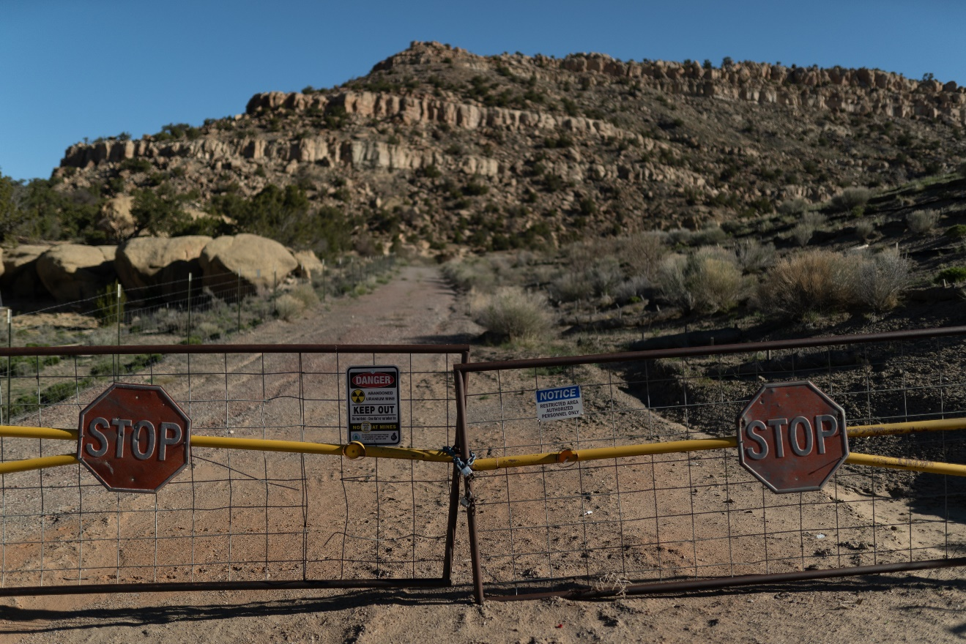

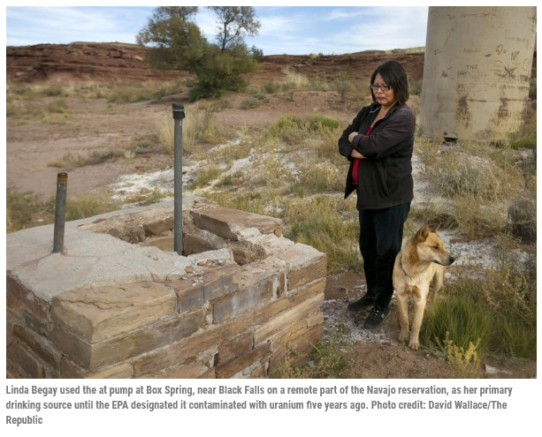

### General Mine Photos – Utah

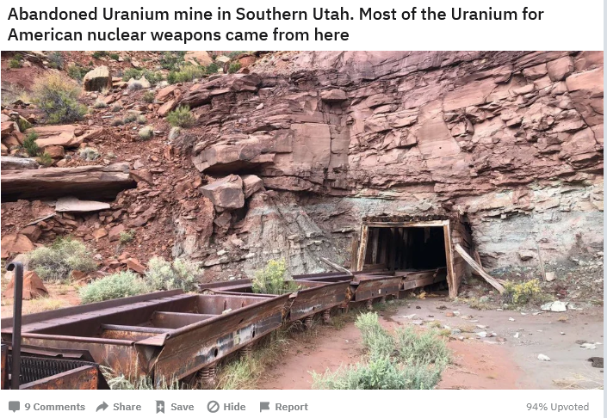

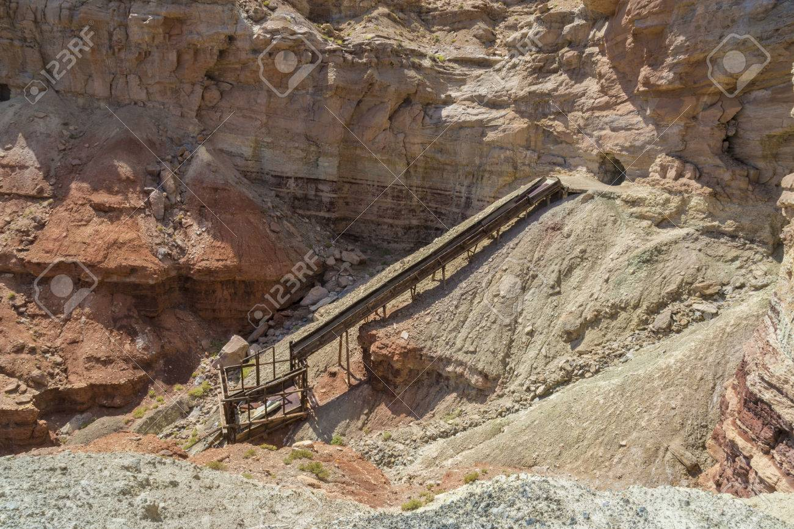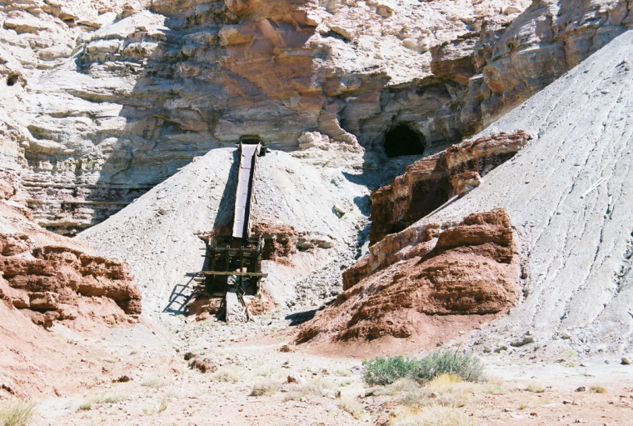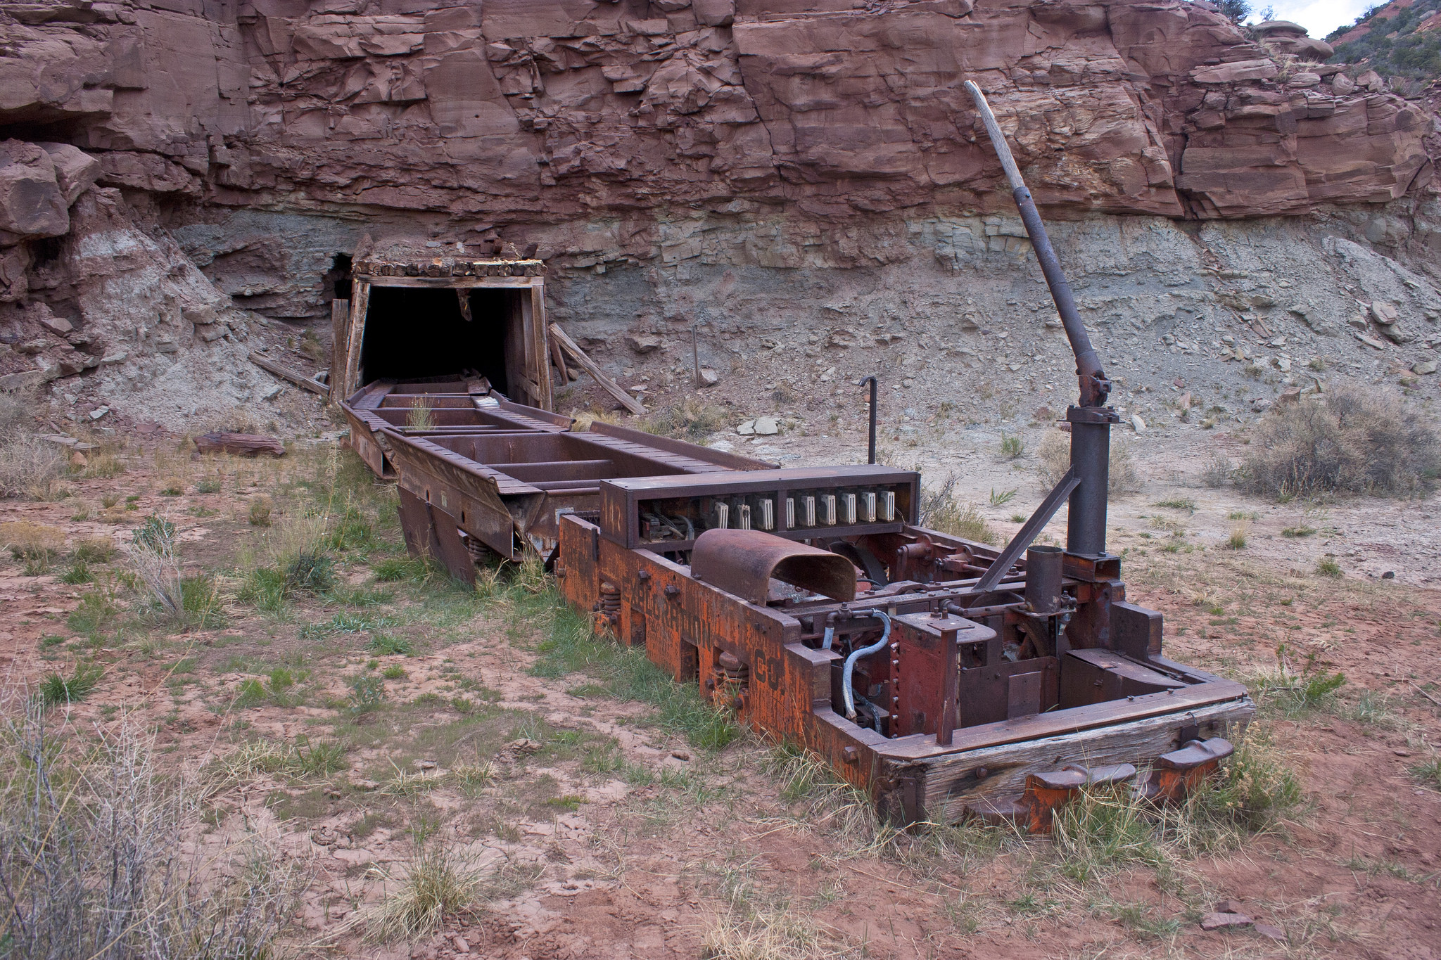

## VISUAL CHARACTER DESIGN (Little Rain God) (TO DO)

Note: it is possible that this character will not be used – but we are trying to preserve some of the students’ original ideas toward the final design. It has yet to be discovered how this character could be used in the final design of the level.

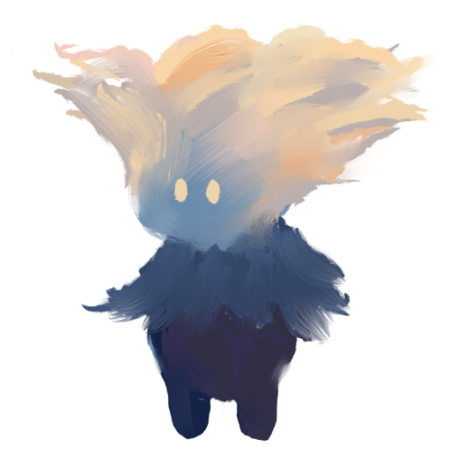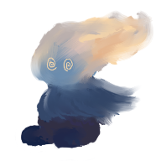

*The Little Rain God will need a walking, jumping, falling, getting up, stun, and hurt animation, with sounds to go with each. Concept Art by Ian McGonigle*

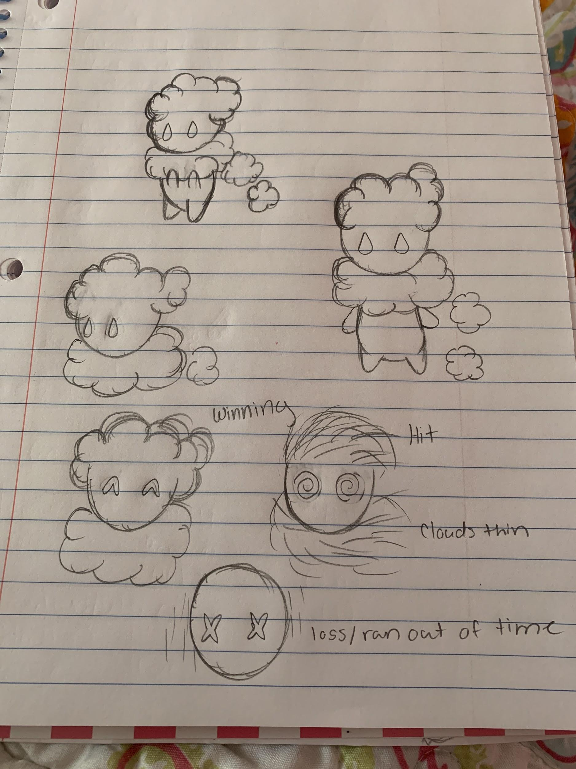

*Concept Art by Madesyn Mathews*

# SONIC ARCHITECTURE

## SOUND EFFECTS: STINGERS

Windy sounds, Thunderclap, Tumbleweed Impact, and Collecting Raindrops in a Bucket sound; Student Game Designers: Ian McGonigle, Rinaldo Del Gallo, Madesyn Mathews, Alvin Thai, Melissa Bridges

## SOUND EFFECTS: TAGS

Rain on plastic container, Bigger Windy Noises, Shiny sounds for sunshine; Student Game Designers: Ian McGonigle, Rinaldo Del Gallo, Madesyn Mathews, Alvin Thai

## MUSIC: INTRO (TO DO)

Yitazba Largo-Anderson to write and compose: <https://yitazba.square.site/>

<https://yitazba.bandcamp.com/releases>

<https://soundcloud.com/yitazba>

<https://distrokid.com/hyperfollow/yitazba/coyote-and-the-stars>

## MUSIC: LOOP (TO DO)

*When players sit idle too long, a peaceful soundtrack will play.*

Yitazba Largo-Anderson to write and compose: <https://yitazba.square.site/>

<https://yitazba.bandcamp.com/releases>

<https://soundcloud.com/yitazba>

<https://distrokid.com/hyperfollow/yitazba/coyote-and-the-stars>

## MUSIC: TRANSITION (TO DO)

*TBD*

# SOFTWARE GAMEPLAY DESIGN AND ARCHITECTURE

The main mechanic in the game will be a shadow illusion. Simplicity will be foregrounded with an influence from Kumi Yamashita <http://kumiyamashita.com/light-shadow>

Note of credit: we are using one of Yamashita’s images to create the mockup and show the idea.

|  |  |
| --- | --- |
| Sun position 1: Sun high in the sky | Position 2: Player moves sun to reveal figures. The position of the sun must be level with the rocks that hold the shadow information, approximately at the horizon, for the figures to appear. |
|  |  |

Actual symbolic imagery will need to be researched but this an example of what is imagined as to how this mechanic can work: Change the position of the sun to control the appearance and disappearance of the illusion. The image is there and must be discovered for the game to progress.

Additionally, we are influenced by this quote from the IAIA Museum of Contemporary Native Arts (MoCNA) and are interested in the key premise that “indigenous peoples of the Americas continue to live, survive and thrive in contemporary society.” The use of the figures appearing from the land shapes when the sun has been moved has the potential to simultaneously speak to the continuance of indigenous people to thrive in contemporary society, the lives lost due to the uranium mines, and the unfinished business of decontamination of the land.

**“**Of the many learning outcomes one may strive for in American Indian studies, this guide will focus on a select few. The knowledge that the indigenous peoples of the Americas continue to live, survive and thrive in contemporary society is the key premise this guide will seek to convey to learners. This contemporary presence is further enhanced by the assertion of a Native intelligence – a way of knowing that may encompass or even exceed the terms and patterns that we have come to associate with American Indian identities, cultures and histories to date.” <https://iaia.edu/mocna/mocna-education/> iaia_mocna_manifestations_curriculum_guide.pdf page 3

The following tables are the history of the design process that happened during 01-2021 and 04-2021 during the NCUIRE

|  |
| --- |
| 03-17-2021 to 03-25-2021 |
| Richard Griffin mechanic: Change the position of the sun and use the sunlight to reveal objects and using shadows to hide obstacles.   * Example: rain cloud becomes atomic bomb mushroom cloud.   Theresa idea: Collect-a-thon water jug to cancer (mini-game?): <https://www.12news.com/article/news/local/arizona/uranium-mines-on-navajo-nation-are-polluting-the-water/75-04f1ef1d-35f5-4988-b11e-19e42ba69e94> |

|  |
| --- |
| 03-17-2021 to 03-25-2021  Games that matches perspective as mechanic: *Luna*, *Superliminal*, *Devil May Cry 5* (Hidden quests: complete symbols to reveal a hidden level [Watchdog QR codes in game serve as lock and actually go to a webpage]), *Braid* and *The Witness, Fez, Monument Valley*  *Superliminal*: <https://www.youtube.com/watch?v=_SX8XMwMw6Y>  Artist that uses the same illusion and was possibly an influence - Felice Varini: <http://www.varini.org/varini/02indc/indant.html>  <https://www.gwarlingo.com/2012/optical-illusions-of-felice-varini/>  *Monument Valley:* <https://youtu.be/wC1jHHF_Wjo>  *Fez*: https://youtu.be/tfpKTclOnfI  M. C. Escher was used as an influence in both *Monument Valley* and *Fez*: <https://mcescher.com/>  *Devil May Cry 5:* (Hidden quests: complete symbols to reveal a hidden level [Watchdog QR codes in game serve as lock and actually go to a webpage]), <https://youtu.be/FjN_S22qnfY>  Artist H.P. Lovecraft was an influence: <https://www.hplovecraft.com/>  <https://symbolikon.com/downloads/lovecraftian-mythos-symbols/>  *Braid:* [*https://youtu.be/hdwvzPkEgcE?t=1606*](https://youtu.be/hdwvzPkEgcE?t=1606)  *The Witness:* [*https://www.usgamer.net/articles/18-04-2018-the-witness-all-puzzle-solutions/page-13*](https://www.usgamer.net/articles/18-04-2018-the-witness-all-puzzle-solutions/page-13)    Art that shifts perspective: [Shigeo Fukuda](https://www.spoon-tamago.com/2015/08/03/illusionistic-shadow-art-by-shigeo-fukuda/) Fukuda was born in Tokyo to a family with a [thriving toy production](https://www.sessions.edu/notes-on-design/designer-focus-shigeo-fukuda/) business.  <https://www.spoon-tamago.com/2015/08/03/illusionistic-shadow-art-by-shigeo-fukuda/>  <http://adcglobal.org/hall-of-fame/shigeo-fukuda/>  “During the 1960’s, Shigeo Fukuda became interested in illusionism. He illustrated a column on visual magic for the daily *Ashai Newspaper*called: “Ryu Mita Ka?” (“Have You Seen the Dragon?”) and he presently presides over *Idea Magazine*‘s “Visual Circus,” an entertaining, bi-monthly feature injected with boyish wit and enthusiasm.” He died in 2009  “I believe that in design, 30% dignity, 20% beauty and 50% absurdity are necessary. Rather than catering to the design sensitivity of the general public, there is advancement in design if people are left to feel satisfied with their own superiority, by entrapping them with visual illusion.”  “In 1980, Fukuda did another marvelous illusionist poster for Amnesty International. It features a drawing of a clenched fist interwoven with barbed wire. That’s not all! The copy at the top simply reads “Amnesty” with the character ‘s’ shaped like a linked shackle. It’s work like this that makes Shigeo Fukuda an impeccable communicator.”  He influenced the Pet Shop Boys <https://youtu.be/InBiaRBUjUs>  Motorcycle Piece: <https://youtu.be/1XfbiziIHmk>  <https://www.pinterest.com/alimasoodimanes/shigeo-fukuda/>  Love the simplicity of this approach: <https://art-sheep.com/kumi-yamashitas-new-light-and-shadow-sculpture/>  <http://kumiyamashita.com/> |

Prior to 03-17-2021

|  |
| --- |
| Magic in the landscape (appearing mountain experience, Devine); Hidden pathways that are revealed via exploration. Certain landscape features offer unique perspective that specifically reveal these pathways. (Griffin)  How Zelda’s puzzles work: <https://youtu.be/pwHqY_4nsJ4>  <https://en.wikipedia.org/wiki/Eiji_Aonuma>  <https://www.zeldadungeon.net/check-out-this-video-exploring-the-zelda-series-puzzle-box-dungeons/>  Hiding and showing parts of the vegetation to create the puzzle and solution.  *Environmental narrative*  *Puzzle narrative with collectables* |

## LOGICAL VIEW (TO DO)

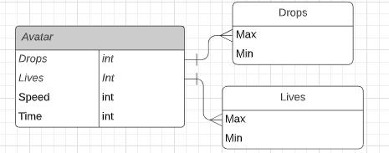

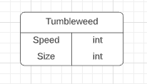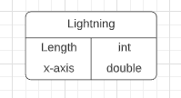

## DATA VIEW (TO DO)

*A relational database that is built in the CORE launcher will be used. This will keep track of numeric values each class uses. The avatar’s speed and health is affected by tumbleweeds and lightning that come into contact with its capsule collider. The number of tumbleweeds and lightning strikes is proportional to drops collected as a storm forms. When the game starts, the avatar has a time limit it can collect raindrops.*

## LOCALIZATION (TO DO)

*The game is available to anyone with virtual museum access worldwide. Adaptations with major languages will be included using translation dictionaries. When publishing the game, it will be usable on Mac, PC, and platform renderings available on CORE.*

## INSTRUMENTATION VIEW (TO DO)

*When creating the project, it will run at intervals to make sure it is working as intended with an IDE. Visual Studio can debug automatically and trace sections of code. Asserts, if-statements, and try-catch statements are usable for exception handling. Profiling can be done with trial and error of different input values. When adjusting colors, hybrid and visual lead can be consulted for desired output. Computer logging should reflect when game objects interact with another by experimenting the game and stimulating for the desired response.*

## SECURITY VIEW (TO DO)

*The game does not require security or memory. Each experience is randomized and the game is short enough that save files are not needed. Hexadecimal mac id filtering can limit the use of this software to museum visitors only.*